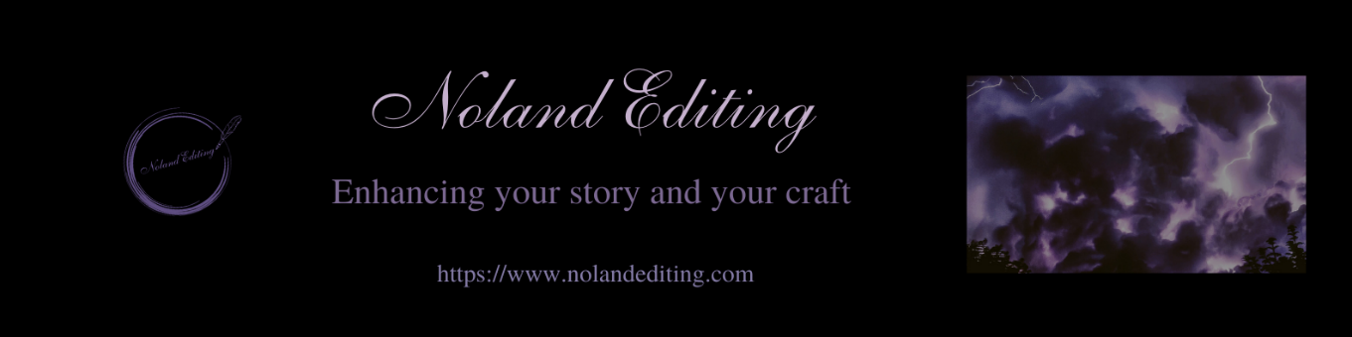

Plot

— Are there any plot holes? ___________
— Do the subplots relate to main plot? ________
— Are plot events clear and understandable? _______
— Is there a logical sequence to the events and plot points? _______
— Is the plot plausible/believable? _________
— Are rising conflicts in the appropriate for place this novel? ________

Characterization

— Are the characters believable and relatable? _____
— Do the characters have clear motivations? _______
— Are the characters well-rounded, with habits, flaws, goals, and needs? _______
— Do characters have arcs and are they believable? _______
— Are characters consistent in their descriptions, actions, and dialogue? _____
— Does each character have a distinct way of speaking? If multiple POVs, do they think differently? _______
— If the story is historical, do they use at least some vocabulary of that time period? _______
— Do they have appropriate emotions, emotional responses, and actions for the age of the characters? ___________
— Is the number of characters appropriate? __________

POV

— Is the POV the best one for this novel? _________
— Is the POV consistent and without head hopping? _________
— Is the number of POV characters too many or too few? ________
— Are the POV characters the best ones? _______

Setting

— Can the setting be pictured clearly without over description? _______
— Is the setting consistent? ___________
— If real places are used, is it accurate? ________

Worldbuilding

— Is the worldbuilding believable for this novel? __________
— Are the worldbuilding rules consistent? ________
— Do the characters’ surroundings influence/affect them appropriately? ______
— Is the layout of the world consistent and believable—something anchored to reality? _______
— Do societies have sound belief systems? __________

Timeline

— Are the events believable within the time span of the novel? ________
— Are the events believable within chapters and scenes? _______

Pacing

— Are the action scenes followed by inaction scenes—refection, planning, emotions? _____
— Are there enough short breaks within action scenes? _______
— Are shorter sentences used in action scenes and longer sentences in inaction scenes? ____
— Does the overall pacing and tension feel right? ________
— Correct amount of backstory and revealed at appropriate times/seamlessly? __________

Dialogue

— Is the dialogue realistic? ________
— Is the dialogue appropriate for the characters’ ages? ______
— Is the dialogue appropriate for the intended audience? _______
— Does the dialogue add to character depth or move the plot? _________

Audience/Writing Style

— Is the content appropriate for the intended audience? __________
— Is the sentence structure and length appropriate for the intended audience? ______
— Does the content meet the audience’s expectations? _________

Messages

— Are the messages clear, without being repetitive or overt? ________
— Are the messages conveyed in an appropriate manner? ________
— Are the messages appropriate for the audience? ________

Genre specific

— Sci-fi — believable technology? _______
— Speculative fiction – believable societal path? ________
— Crime/mystery – believable police and detective actions/procedures and crime? ______
— Romance – believable romantic tension, appropriate length of build-up, and scenes appropriate for this novel? ___________
— Paranormal – correctly based on mythology, believable new mythology? _____
— Magic — believable powers, spells, abilities, and consequences? ______
— Apocalyptic — believable outcome and consequences of apocalyptic event? ______
— Dystopian — believable belief and societal structure? ___________

