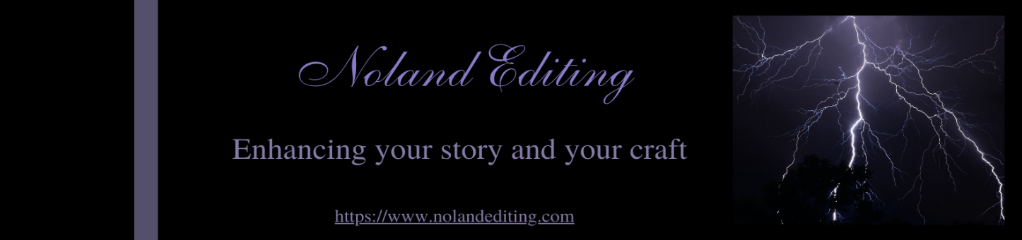

Worldbuilding Guide
All fiction needs worldbuilding. Even if your story is based in a real town on Earth in the present day, you should still answer some of the questions in this guide. Every fantasy and science fiction novel should have some tether to reality, or your readers may not understand the world put so much effort into creating.

This is not a comprehensive guide and should be used to spark your worldbuilding journey.

The Big Questions
What is your world called? __________________________

Is it Earth, Earth in the future or past, Earth-like, a different planet altogether? _______________

How was the world created and how long ago? If future Earth, how did it change and how long did it take to get to when your story based? _____________________________________________________________________________

How do the laws of physics work? For example, if it is a planet in our solar system and you have human inhabitants, how do the differences in gravity and air affect them? If they have compensated for that, how did they do so? ________________________________________________________________________________________________________________________________________________________________________________________________________________________________________________________________________________________________________________________
How does the flora differ from region to region?
____________________________________________________________________________________________________________________________________________________________
Do any plants have special properties? Healing or harmful? ____________________________________________________________________________________________________________________________________________________________
Are there the mountains? Forests? Deserts? Rivers? Seas? ____________________________________________________________________________________________________________________________________________________________

How do the inhabitants interact with the terrain? For example, are seas polluted and no one can live on the coast? Are the forests the places that are feared most and why? ____________________________________________________________________________________________________________________________________________________________

Are there diseases? Have they evolved? How are they transmitted? How has this affected population growth or plant life? Did the rulers create a disease? If so, for what purpose?
____________________________________________________________________________________________________________________________________________________________

What are the major cities? Most populated areas? Best places to live? Worst places to live? ____________________________________________________________________________________________________________________________________________________________

How are the countries, cities, sections of cities identified? Street names, colors, flags? (This could also tie in with culture identifications.)
____________________________________________________________________________________________________________________________________________________________

What is the climate or weather like? How does this affect the landscape and inhabitants?
____________________________________________________________________________________________________________________________________________________________

The Inhabitants
Who inhabits your world? Humans? Elves? AI? Mages? Other?
______________________________________________________________________________

How many inhabitants are there in your world? ________________________________________

How many of each species? _______________________________________________________

How well or how poorly do they co-exist?
____________________________________________________________________________________________________________________________________________________________

What do they think about each other? Tolerance, look down on others?
____________________________________________________________________________________________________________________________________________________________

What do the inhabitants of your world look like? What are the species’ distinguishing features?
____________________________________________________________________________________________________________________________________________________________

How do they communicate? Different languages? Telepathically? Gestures? Expressions?
____________________________________________________________________________________________________________________________________________________________

What is considered an insult? Is there slang? One universal language but also sublanguages?
____________________________________________________________________________________________________________________________________________________________

What are the societal norms and deviations from the norms?
____________________________________________________________________________________________________________________________________________________________

What is the society’s structure? Class system, caste system?
____________________________________________________________________________________________________________________________________________________________

Are there religions? How do the religions differ? How do the religions affect the inhabitants? Wars over them? Tolerance?
____________________________________________________________________________________________________________________________________________________________

Do ceremonies take place? How and when are they performed?
____________________________________________________________________________________________________________________________________________________________

What is the normal family structure?
____________________________________________________________________________________________________________________________________________________________

What do the inhabitants eat? How many times a day do they eat and when?
____________________________________________________________________________________________________________________________________________________________

Is there magic in your world? Who has access to the magic? What are the limitations?
____________________________________________________________________________________________________________________________________________________________
The Societies
What are the rules or laws of each society?
____________________________________________________________________________________________________________________________________________________________

How does the society handle the deviations? Laws, punishments?
____________________________________________________________________________________________________________________________________________________________

Who decides on the laws and punishments? Society, government?
____________________________________________________________________________________________________________________________________________________________

What is the governmental structure of each society? Dictatorship? Socialism? Monarchy? Democracy?
____________________________________________________________________________________________________________________________________________________________

What is the currency? Does each society have a different type?
____________________________________________________________________________________________________________________________________________________________

Do the inhabitants work for money? Food?
____________________________________________________________________________________________________________________________________________________________

Remember, this is not a complete list, but questions to get you started building your world.

Worldbuilding is exciting and can be a rabbit hole, so try not to get caught up in it and not write. And it may change because your characters may take you on a journey you didn’t expect!

